**Attendance Taking System**

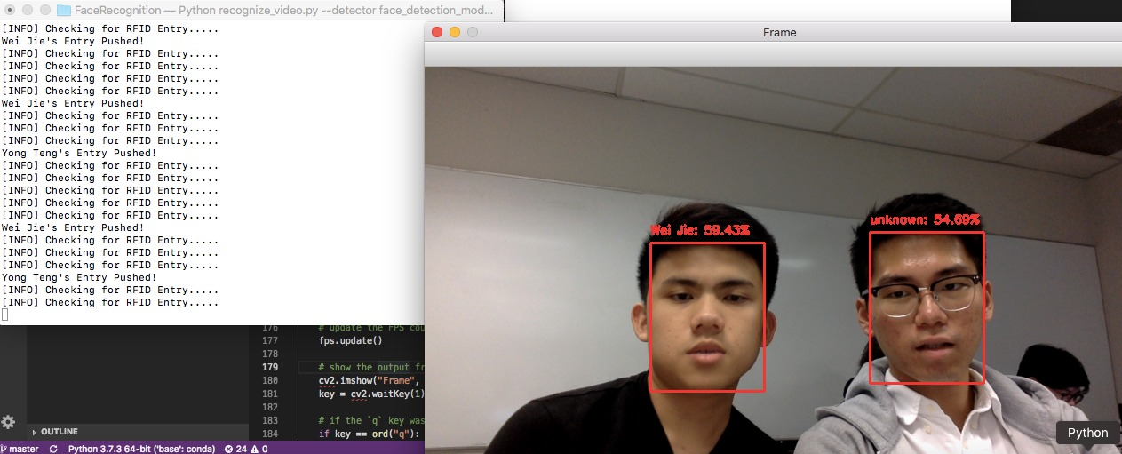

Event Date: 4 FEB 2020

Event Venue: E-Garage

Creator: Ang Wei Jie & Tee Yong Teng